Begin forwarded message:

From: "Met Opera" <NoReply@metopera.org>
Subject: Critical Acclaim for Roberto Alagna and Aleksandra Kurzak Live in Concert
Date: 19 August 2020 at 20:08:34 GMT
To: bsim@hi.is

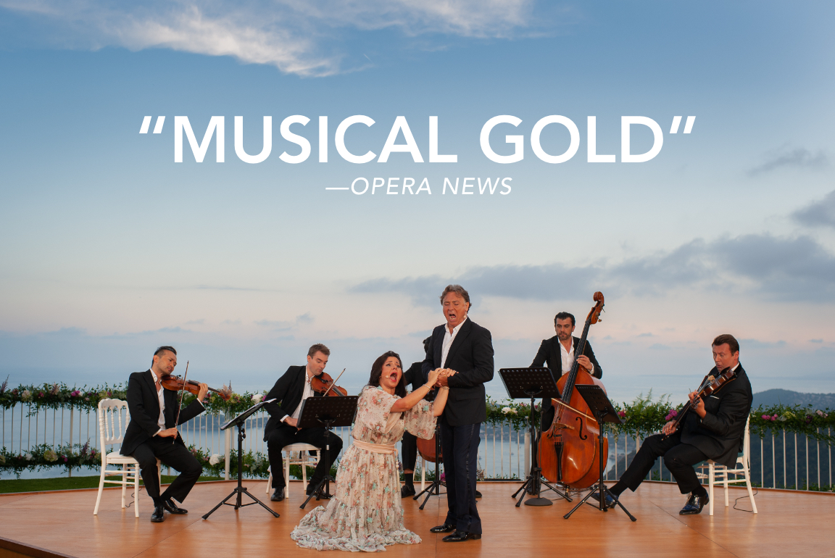
Last weekend, tenor Roberto Alagna and soprano Aleksandra Kurzak gave an enchanting performance live from the French Riviera as part of the hit Met Stars Live in Concert series. Read what the critics had to say about this breathtaking concert—which is available for on-demand viewing through August 27.
BUY TICKETS
WATCH TRAILER

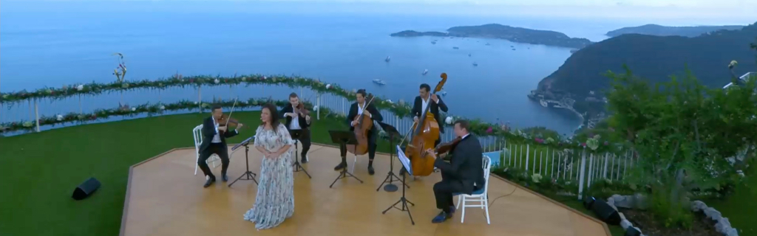
“The couple’s chemistry and stylistic surety produced musical gold … tailor-made for the twilit beauty of the Èze backdrop … [Kurzak delivered] pristine clarity and shimmering delicacy ... [alongside] resonant singing from Alagna.”
—OPERA NEWS
“The setting was gorgeous … [and the concert was] moving and richly sung … it was good fun.”
—ST. LOUIS POST-DISPATCH
“Video as good as a movie theater; the sound was probably better.”
—THE WALL STREET JOURNAL
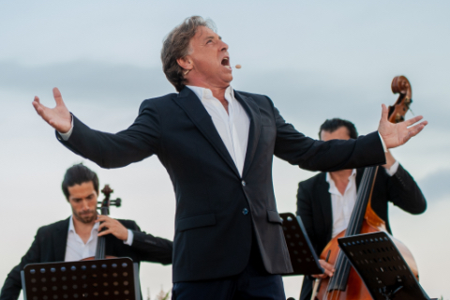
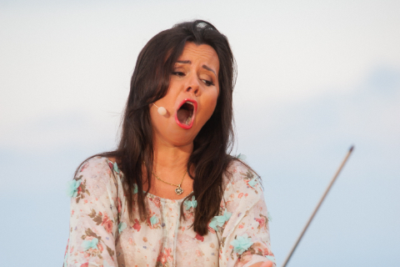
“The operatic couple, both on stage and off, turned a hilltop village into a fiery opera stage … Aleksandra Kurzak was in top form and at the height of her talents.”
—ÔLYRIX (France)
“A spectacular view of the Mediterranean—made all the more spectacular by a truly dazzling performance from Kurzak and Alagna … It is becoming clear that the Met’s Live in Concert series is fast becoming the most essential operatic viewing of the pandemic.”
—PARTERRE BOX
BUY TICKETS

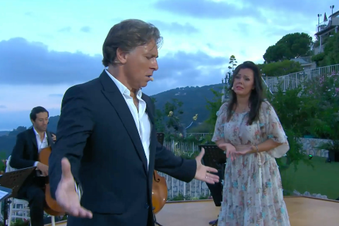
Watch the trailer for Roberto Alagna and Aleksandra Kurzak’s enchanting performance.
WATCH TRAILER

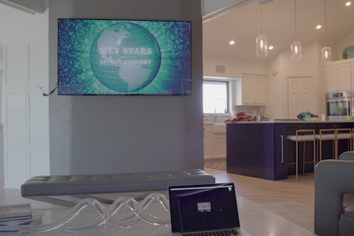
Need help streaming the performance? Follow these step-by-step instructions to watch Met Stars Live in Concert on your television using Google Chromecast or Apple AirPlay.
WATCH VIDEO

Aleksandra Kurzak and Roberto Alagna sing “Vogliatemi bene” from Puccini’sMadama Butterfly.
WATCH VIDEO

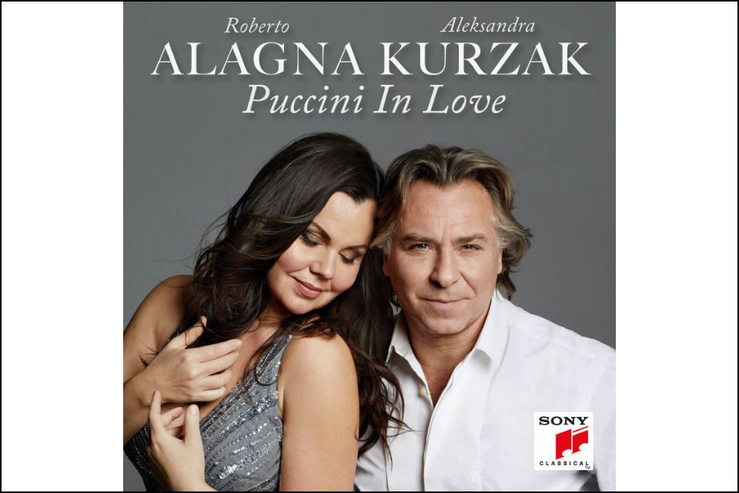
On their Puccini in Love album, Alagna and Kurzak sing some of the composer’s most passionate duets, featuring selections from La Bohème, Tosca, Madama Butterfly, and more.
BUY NOW

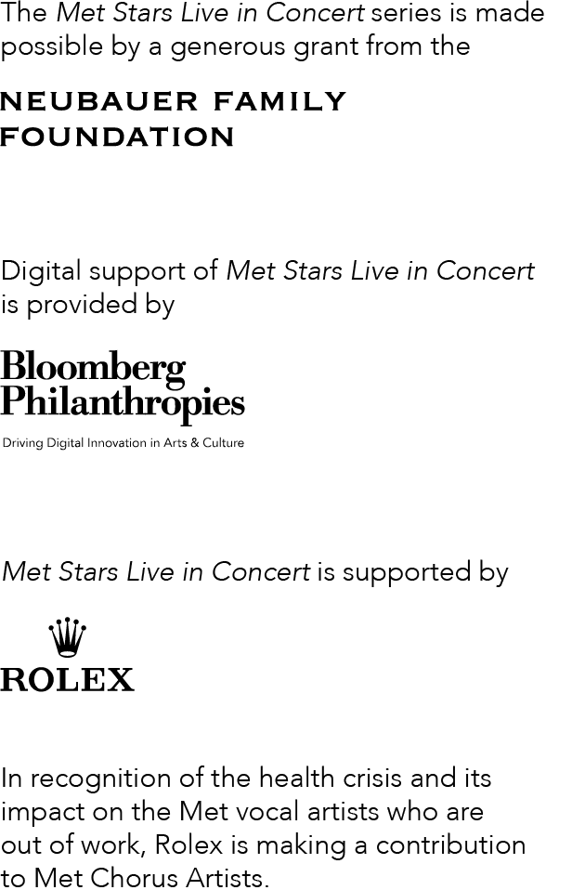

FOLLOW US

CUSTOMER SUPPORT
Contact Us
Unsubscribe or Manage Email Preferences
View this email in a browser

© 2020 METROPOLITAN OPERA
30 Lincoln Center
New York, NY 10023
212.362.6000
metopera.org
Peter Gelb, General Manager
Yannick Nézet-Séguin, Jeanette Lerman-Neubauer Music Director

Photos: James Pouliot / Met Opera
This message was sent to bsim@hi.is because you've signed up to receive Metropolitan Opera emails or agreed to our Terms & Conditions. Review our Privacy Policy.

